Exercise 1: First I create a file called greeting.java. And gave a class greeting. Then I called main and use prinln () to display a text.

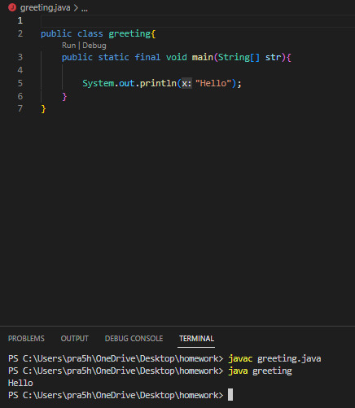

Exercise 2: First I created a file Calc.java. Then gave it class Calc. I called main and returned the sum of its argument with the help of + operator. And used println() to display the sum.

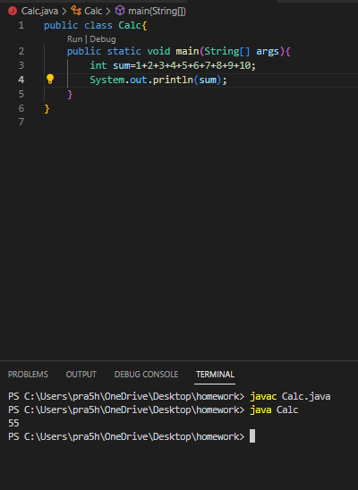

Exercise 3: First i created a file called Multiplication.java. Then I gave it a class Multiplication. I called main and multiplied with the help of \* operator. And used println() to display the multiplication.

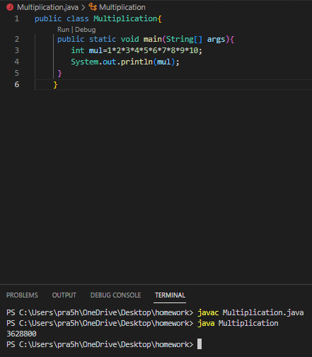

Exercise 4: First I created a file interest.java and gave it a class interest. Then I called the main and gave value and calculated the sum using simple interest. Finally, used println() to calculated the total.

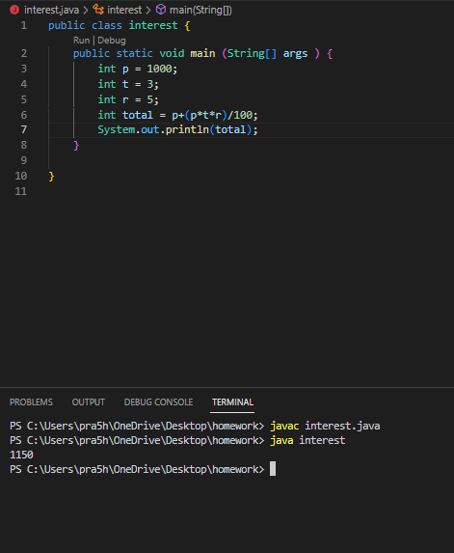

Exercise 5: First I created a file Name.java and gave it a class Name. Then I called main and printed my name inside using underscore and vertical bar.

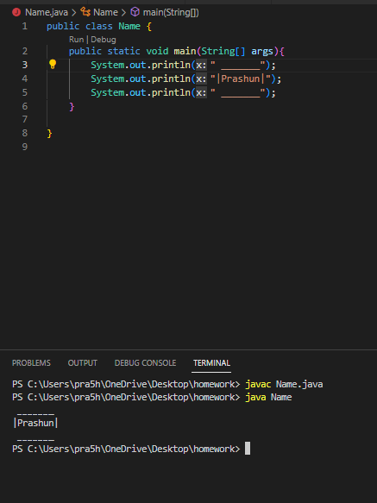

Exercise 6: First I created a file largename.java and gave it class largename. Then I called main and inside println() used asterisk \* to created my name in big pattern.

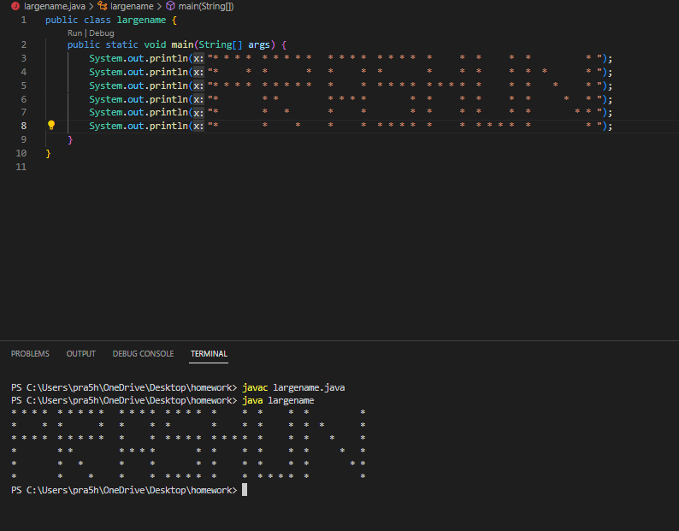

Exercise 7: First I created a file face.java and gave it a class face. Then I called main and inside println I created a face using different symbol.

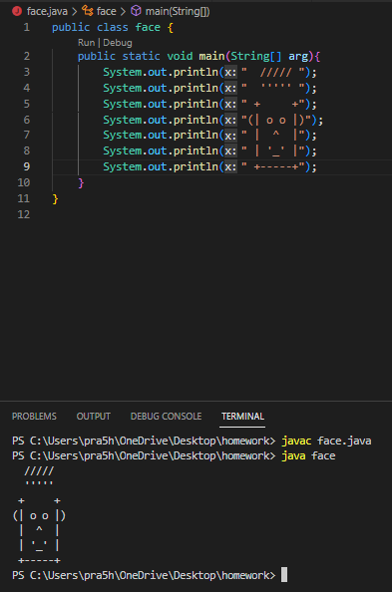

Exercise 8: First I created a file House.java and gave it a class House. Then I called main and inside println I created house using different symbol.

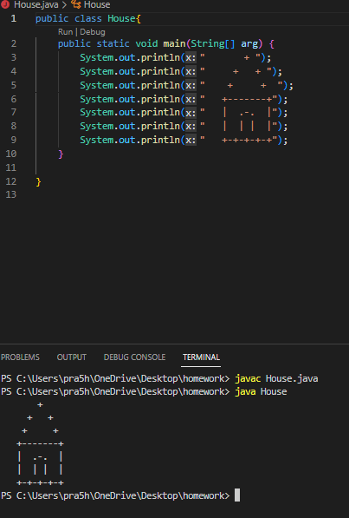

Exercise 9: First I created a file Animal.java and gave it class Animal. Then I called main and printed a animal using different symbol.

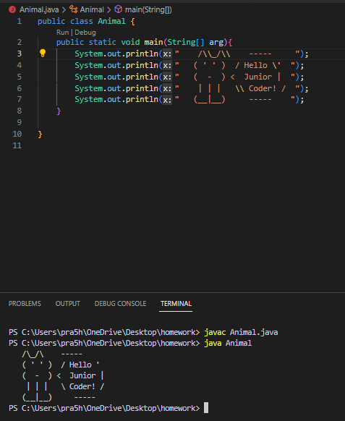

Exercise 10: First I created a file Movies.java and gave it class Movies. Then I called main and printed the movies name in three lines.

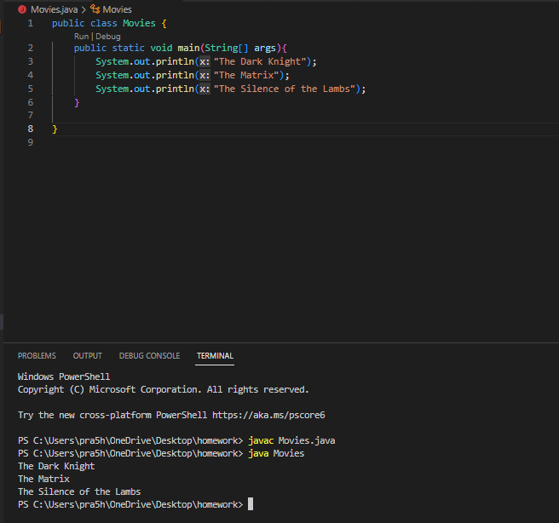

Exercise 11: First I created a file DialogViewer.java and typed in the program given by question. And on JOptionPane, I changed Hello, World! Message to Hello, Prashun.

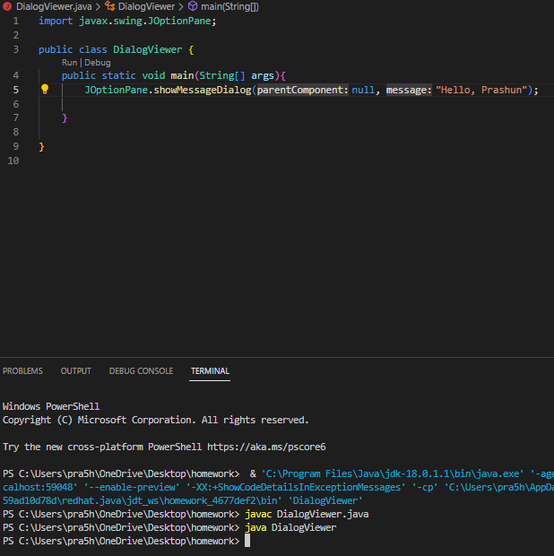

Exercise 12: First I created file DialogViewer2.java and gave it class DialogViewer2. Then I typed the program given by the question but inside println() I wrote “Hello, and inside + operator wrote name”.

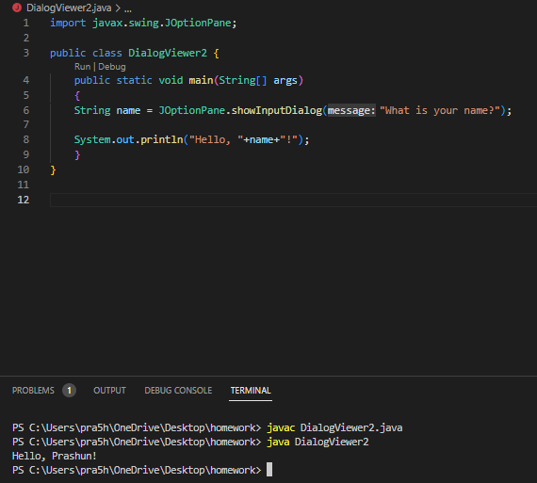

Exercise 13: First I created a file Test.java and gave it a class Test. Then I typed the given program but change the url and changed Hello message to Prince of Darkness and also I change the title to Ozzy Osbourne.

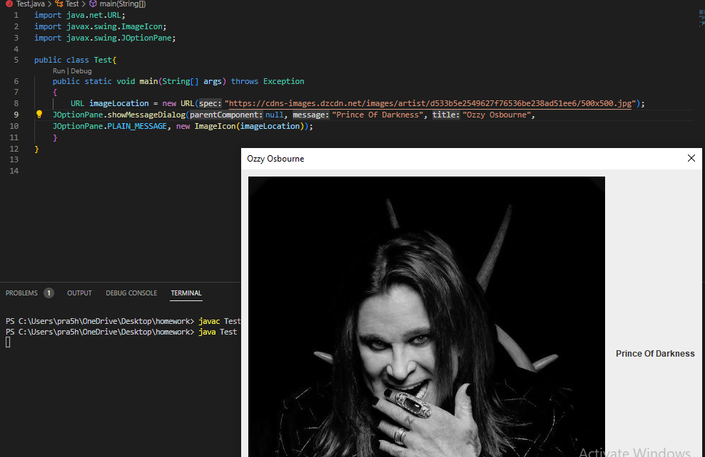

Exercise 14: First I created a file Phrase.java and gave class Phrase. Then I called main and printed the phrase in both English and Portuguese.

